GOULBURN ANNUAL TOURNAMENT
12 & 13 May 2007
At “Springfield”, Goulburn
Herewith the list of teams and draw for this weekend and some information about the Tournament.
Directions
“Springfield” is located 19 kms south of Goulburn on the Braidwood Road - Look for the Goulburn Polo Club flags at the entrance on your right.

Hospitality
We have arranged a Dinner Dance in the Club House on Saturday night. This function is already substantially booked by our members, but we have held back a large block for visiting players. If you would like to make a reservation, please let us know how many places you would like us to reserve for your team (including grooms and guests). Cost will be $40 (a full bar will operate). We will keep your places until midday on Saturday but we do ask that people reserving places pay for them by then.
Our Club Secretary, Denise McMurtrie will be at the Club House for this purpose.
Lunch will be available in the Club House both days. Tea and Coffee are complimentary.

Chukka Fees
Chukka fees will be $160 per player for the weekend. Would Team Captains please pay our Club Secretary, Denise McMurtrie, on Saturday morning. She will be at the Club House all Saturday morning. No team may take the field on Sunday unless its fees are paid in full.
It is the responsibility of all players to be registered to play in NSW for insurance purposes. If a team presents with a player not appearing on the NSW Polo web-site, the team will have its handicap increased by one goal (per player not registered). Please don’t make us do this; we want the weekend to run happily, smoothly and safely for all. If in doubt about your registration please call Suzie Ruse at NSWPA: 9388 9593 or 0424 24 3369.

Saturday Dinner Dance – Priority Booking for Players & guests

Please reserve places for Dinner (@$40 per head)

Please fax to 4842 2675 by 5.00 pm, Friday or book in and pay at the Club-house on Saturday morning, to secure a reserved place.
NB: payable by midday on Saturday to confirm reservation.
Signed: Name:
Contact No: Fax No:

GOULBURN ANNUAL POLO TOURNAMENT
12 & 13 MAY 2007

THE TEAMS
A Grade (6 chukkas)
GOULBURN A  1. Stirling McGregor 3  2. Callum MacLachlan 2  3. Angus Campbell 3  4. Simon Walker 4  12 | SPRINGDALE  1. Edward Bradley -1  2. Robert Ballard 4  3. Craig Wilson 6  4. Joe Curran 3  12
MILLAMOLONG  1. Rick McCarthy 3  2. Aaron Vowles 4  3. Dirk Gould 4  4. Wallace Ashton 1  12 | SYDNEY  1. Peter Higgins 1  2. Mark Field 4  3. Guy Kirkpatrick 4  4. Greg Ballard 2  11
B Grade (5 chukkas)
GOULBURN B  1. Nick Wills 0  2. Brendan Fahey 2  3. Mark Lillyman 4  4. Shane McLaughlin 2  8 | WINTEN  1. Dick Rodgers -1  2. Adam Tolhurst 4  3. Hamish McGregor 4  4. Dave Rothwell -1  8
JEMALONG  1. Marcus Kahlbetzer 1  2. John Kahlbetzer 2  3. Juan Losada 4  4. Edward Thirlwall 1  8 | GUNDALONG  1. Lachlan Graham 1  2. Angus Graham 3  3. Edward Gould 4  4. Skye MacLachlan -1  7
FOLLY LODGE/ HOWMEDICA  1. Matthew Howard 0  2. Rick McCarthy 3  3. Mark Field 4  4. James Burkitt 0  7 | ADELAIDE EQUITY  1. Danny Damen 0  2. Martin Ingham 1  3. Robert Ballard 4  4. Mark Lindh 1  6

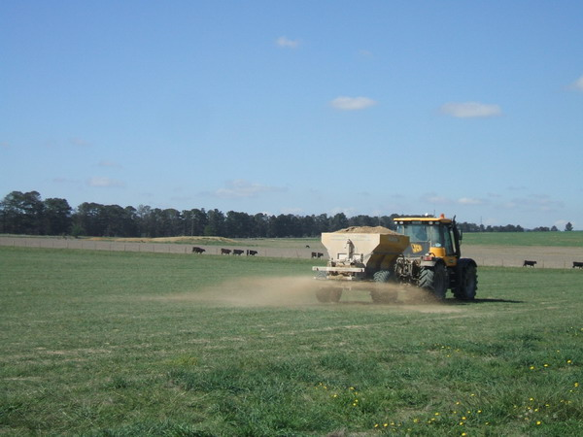 | 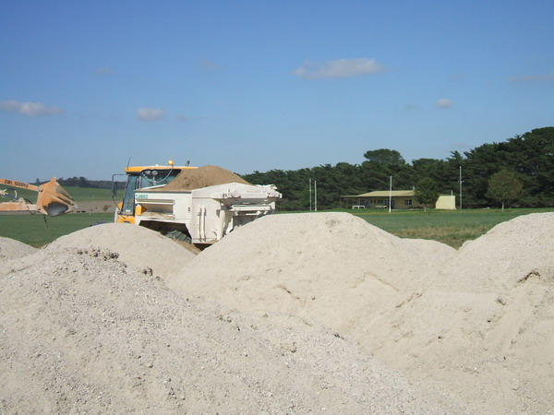

THE TEAMS (cont)

C Grade (4 chukkas)
GOULBURN C  - David Dunn -1  - Greg Darmody 0  3. Simon Walker 4  4. Greg Read 1  4 | SINGAPORE  1. Debbie Daniher -1  2. James Ashton 0  3. Satar Kahn 4  4. Eugene Marias 1  4
CANONBAH BRIDGE  1. Mike deMestre 0  2. Chris Barber 0  3. Shane McLaughlin 2  4. Tim Darby 1  3 | FOLLY LODGE  1. Sam Ballas -2  2. Roger Fagan 0  3. John Kahlbetzer 2  4. Richard Rawlings 4  4
AYC  1. Arhur Yenkin 0  2. Nicole Brown 0 1  3. Sam Hunt 2  4. Chris McCarthy 0  2 | SYDNEY COUNTRY POLO CLUB  1. Rebecca Higgins -2  2. Matt Anderson -1  3. Raymond Bruce 1  4. Mark Lillyman 4  2



GOULBURN POLO &  PICNIC RACE CLUB INC.  PO Box 489  Goulburn NSW 2580 | CONTACT NUMBERS  SECRETARY Denise McMurtrie – telephone 4842 2707• facsimile 4842 2675• mob 0419 919 001  PRESIDENT James Bell - tel 9221 2244 (w) 9363 4048 (h) • fax 9221 2264 • mob 0428 48 2101  CLUB CAPTAIN Simon Walker – telephone 6227 6066 • facsimile 6227 6222 • mob 0408 494 773  IMMEDIATE PAST PRESIDENT Richard Maple-Brown - telephone 4829 5110 • facsimile 4829 5121

GOULBURN ANNUAL POLO TOURNAMENT
12 & 13 MAY 2007 - THE DRAW

SATURDAY, 12th MAY 2007
WEST GROUND - (NEAR CLUB-HOUSE)

MATCH A Howmedica v Goulburn B
Time 9.00 Umpires Timekeeper/Referee Sinclair Bell
Stirling McGregor Goal Umpires Danny Damen
Martin Ingham Dick Rodgers

MATCH B Jemalong v Gundalong
Time 10.15 Umpires Timekeeper/Referee Brendan Fahey
Angus Campbell Goal Umpires James Burkitt
Rick McCarthy Matthew Howard

MATCH C Winten v Adelaide Equity
Time 11.30 Umpires Timekeeper/Referee Marcus Kahlbetzer
Angus Graham Goal Umpires Nick Wills
Juan Losada Edward Thirlwall
MATCH D Goulburn v Sydney
Time 1.00 Umpires Timekeeper/Referee Dirk Gould
Aaron Vowles Goal Umpires Edward Bradley
Craig Wilson Wallace Ashton
MATCH E Millamolong v Springdale
Time 2.30 Umpires Timekeeper/Referee Mark Field
Adam Tolhurst Goal Umpires Callum MacLachlan
Guy Kirkpatrick Peter Higgins

EAST GROUND – (NEAR ROAD)
MATCH F Goulburn C v AYC
Time 9.15 Umpires Timekeeper/Referee Andrew Blake-Dyke
Greg Ballard Goal Umpires Debbie Daniher
Satar Kahn Matt Anderson

MATCH G Singapore v Sydney Polo Club
Time 10.30 Umpires Timekeeper/Referee Greg Darmody
Greg Read Goal Umpires Arthur Yenkin
Sam Hunt Chris Barber

MATCH H Folly Lodge v Canonbah Bridge
Time 12.30 Umpires Timekeeper/Referee James Ashton
Mark Lillyman Goal Umpires Chris McCarthy
Eugene Marias Raymond Bruce

SUNDAY, 13th MAY 2007
WEST GROUND - (NEAR CLUB-HOUSE)

THE BELL TROPHY FINAL – C GRADE
MATCH I 1ST IN C GRADE v 2ND IN C GRADE
Time 10.00 Umpires Timekeeper/Referee
Goal Umpires

MRS A.R. MAPLE-BROWN CUP FINAL – B GRADE
MATCH J 1ST IN B GRADE v 2ND IN B GRADE
Time 11.00 Umpires Timekeeper/Referee
Goal Umpires

THE GUS COOPER CUP FINAL – A GRADE
MATCH K LOSER MATCH D v LOSER MATCH E
Time 1.00 Umpires Timekeeper/Referee
Goal Umpires

ASHTON CUP FINAL – A GRADE
MATCH L WINNER MATCH D v WINNER MATCH E
Time 2.30 Umpires Timekeeper/Referee
Goal Umpires

EAST GROUND - (NEAR ROAD)

The draw for the East Ground will be posted in the Club House on Saturday night. Every effort will be made to accommodate players doubling up; however, the finals will not be moved and if a clash is unavoidable a player doubling up will be expected to get a replacement for his losers’ game.
MATCH M v
Time Umpires Timekeeper/Referee
Goal Umpires

MATCH N v
Time Umpires Timekeeper/Referee
Goal Umpires

MATCH O v
Time Umpires Timekeeper/Referee
Goal Umpires

MATCH P v
Time Umpires Timekeeper/Referee
Goal Umpires

