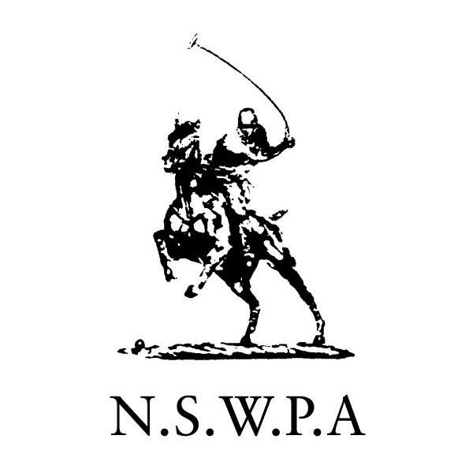

PROPOSED CHANGES to NSWPA (Kyeemagh) CONSTITUTION
Rules for Club Affiliation

These rules apply to all new and continuing Club affiliations:

1. Three Categories of Club:
a. Members Club
b. Patron Club
c. Passive Club

2. Members Clubs
- Must have more that 5 registered playing members
- Must hold an annual tournament at which all NSW clubs are invited to play. The annual tournament must provide for a low goal competition and efforts must be made to accommodate as many players as possible given demand and level of facilities
- Must have control of one or more polo fields
- Must be properly constituted as an incorporated association or company with limited liability
- Must supply a set of annual financial statements to the NSWPA each year
- Must be structured so that more than two unrelated persons have control over its operations. For the purpose of this provision, an associate and/or employee of an office bearer is/are considered related person/s.

3. Patron Clubs
- Must have at least 4 registered playing members
- Must hold an annual tournament at which all NSW clubs are invited to play, in at least one grade. Patron clubs are not required to provide polo at more than one grade
- May be controlled by one person
- Must have control of one or more polo fields. The NSWPA Board may, at its discretion, allow a period of up to three years for a patron club to establish it has control of a field.
- Must satisfy the NSWPA that it is financially capable of honouring its obligations. This may be accommodated by provision of personal guarantee/s by the person/s controlling the club, or may be satisfied if the NSWPA forms the view that the entity affiliated as the club has sufficient net worth (eg. by virtue of being registered proprietor of the land used for the polo fields).

4. Passive Clubs
- Include:
  - former Member Clubs that no longer fulfil the requirements needed to remain a Member Club
  - clubs which do not satisfy the requirements of either Member Club or Patron Club but wish to have their own identity
  - supporter groups
- Passive clubs may not conduct polo tournaments or practises in their own right. They may however engage with a Member Club or Patron Club to carry on a tournament or practise in conjunction. In these circumstances control over play and all on field safety issues must be the sole responsibility of the Member or Patron Club.

5. Voting
- All categories of club are important to the goodwill and growth of polo. Accordingly, they all warrant representation in NSWPA decisions. In addition, the NSWPA constitution currently provides for categories of members, being A Members, B Members and Life Members. A revised governance structure must recognise the legitimate interests of each member category.
- At each Annual General Meeting NSWPA directors will be elected by Life members and club category as follows:
    - Life Members - 4 Life Directors
    - Member Clubs - 11 Directors
    - Patron Clubs - 2 Directors
    - Passive Clubs - no Directors
c. At no time can the Board of the NSWPA be constituted of more than two (2) Directors affiliated through Patron and/or Passive Clubs.

6. Provisional Affiliation
        - Affiliation of all new clubs will be on a provisional basis for 2 years.

7. Over-ride Provision
a. The NSWPA Board reserves the right at any time to determine whether an entity satisfies the requirements of a Member Club, and may in its absolute discretion determine that an entity shall be classified a Patron Club or Passive Club. Upon such classification there shall be no right of appeal.

