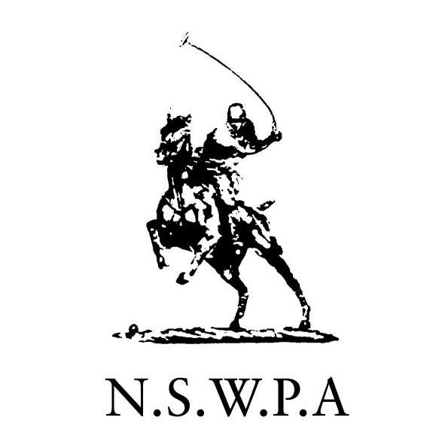
PO Box 957
Bondi Junction NSW 1355

22 January 2008
Dear Clubs and Players

2008 INSURANCE UPDATE
AND
NOTICE OF NEW PLAYER REGISTRATION PROCEDURES AND PENALTIES.

Welcome to 2008 – and hopefully the end of the Equine Influenza epidemic in Australia.

2008 is also the year that sees the introduction of the APC Hold Harmless Deed that is designed to operate Australia-wide. Every player is now required to sign this version of the Deed.

INSURANCES
I am pleased to report that the Australian Polo Council’s National Insurance Scheme (NIS) continues to operate successfully. This year the APC’s broker, Simon Tait of EBM Insurances Brokers Pty Limited, has negotiated a significant decrease in the premiums payable by our Clubs. (See the calculations below) The NSWPA thanks Simon for his continued efforts on our behalf. They have yielded solid rewards for our community.

Please carefully read the insurance information set out below and follow the procedures to make the formal side of our operations flow smoothly.

Simon has also reported that we now have every polo Club in Australia subscribing to the APC’s National Insurance Scheme. This is a bonus for our community.

NEW PLAYER REGISTRATION PROCEDURES AND PENALTIES
While I am pleased to report that overall the majority of Player Registrations were processed more efficiently in 2007, we still encountered a few significant problems. The NSWPA Board has therefore resolved to go hard on Player Registrations in 2008. A new procedure and program of penalties will apply this year.

Going forward, it will be the player’s responsibility to ensure that he/she is registered on the NSWPA website before participating in any polo activity. Non compliance now attracts the following penalties:

1st offence: suspended from play the following weekend (or the weekend following detection)
2nd offence: suspended from play for the next month after the infringement occurred/was detected
3rd offence: suspended from play for the next month after the infringement occurred/was detected plus a $500 fine.

We therefore recommend that all players support their Clubs and tournament organizers by:
- paying their affiliation fees promptly; and
- providing their Clubs with a properly completed 2008 APC Hold Harmless Deed
well in advance of the date they wish to take part in any polo activity. Club officials need adequate time to process memberships and registrations.

Please email or call me if you have any queries.

Yours sincerely
Suzie Ruse
Secretary, NSW Polo Association

SUMMARY of 2008 Club and Player Registrations and Insurance Issues

The 2008 NSWPA Affiliation Fees Notice is attached. Please read it carefully.

PLEASE NOTE:

- CLUB AFFILIATION:
Clubs are requested to finalize their affiliation by 28 February 2008.

The NSWPA cannot accept players’ fees directly which means that playing members of unaffiliated Clubs cannot take to the field until both their Club and player registrations have been completed and entered on the website.

Procedure for Club Affiliation:

The Club must pay:

- its Club Affiliation Fee of $1,200 (plus GST) to the NSWPA; and
- its NIS insurance premium directly to the APC’s brokers, EBM. EBM will be issuing tax invoices for Club premiums in early February 2008. Once the premium has been paid, EBM will provide the NSWPA with a copy of the Club’s Certificate of Currency of Insurance to complete the Club Affiliation process.

- PLAYER AFFILIATION:
The NSWPA Club and Player categories remain the same as last year.

Clubs continue to be responsible for processing their playing members’ affiliations and website registrations. However, this year, as set out above, it is now the player’s responsibility to provide their Clubs with payment of their fees and completed new version 2008 APC Hold Harmless Deeds.

We ask each Club to circulate their Player Affiliation Notices early and to put their members on notice of the new penalties.

Coaching Clinics
The Coaching Clinic Participant Category has been maintained. When running a clinic, please make sure to obtain from each participant:
- a properly signed 2008 APC Hold Harmless Deed before allowing them to take part in the clinic;
- a contribution of $11.00 (incl GST) for insurance cover. This contribution covers the player for the duration of the clinic (from 1 to a maximum of 7 consecutive days).
The Club must then provide NSWPA with a schedule detailing the date and venue of the clinic, the names of the participants and payment for aggregated insurance contribution.

- The 2008 APC Hold Harmless Deed contains a Player Acknowledgment that they are aware of all of the Policies and Regulations prescribed by the APC and their State Association from time to time as posted on the Australian Polo website: www.australianpolo.com.au

We ask for the cooperation of our Clubs in drawing their members’ attention to their responsibilities in this regard.

As always, we wish you all a very safe and enjoyable year of polo.

Best regards
Marlene MacFarlane
Director – Insurances

SUMMARY OF INSURANCES - 2008

This year the NSWPA and our affiliated Clubs and registered players will have the benefit of the following insurance cover:

- PUBLIC LIABILITY INSURANCE

Details of the substantive cover provided by the Australian Polo Council’s (APC) National Insurance Scheme (NIS) policy has been circulated to all Clubs in previous years.

Please note: The limit of Indemnity is $20million and an excess of $1,000.00 per occurrence applies.

The Underwriter is QBE Commercial Limited.

PREMIUMS

NSW POLO ASSOCIATION (KYEEMAGH) LIMITED

2008
$1,200.00 plus provision of
plus GST and State Government Stamp Duty TOTAL $1,438.80

PLEASE NOTE that the NSWPA also pays the insurer a contribution of $47.96 (incl Stamp Duty) per Player from the individual Player affiliation fees of $350.00.

NSWPA AFFILIATED POLO CLUBS

2008 premium 2007 premium
$800.00 plus GST plus $1,000.00 plus GST plus
Stamp Duty Stamp Duty

TOTAL $959.20 TOTAL $1,199.00

PAYMENT PROCEDURE
(a) EBM will issue you with a Tax Invoice for your Club’s share of the NIS premium
(b) Your premium must be paid directly to EBM
(b) EBM will then issue your Club with a Certificate of Currency of Insurance
- You must either immediately provide of copy of this Certificate to
The Secretary, NSW Polo Association to complete your annual affiliation
OR
Arrange for EBM to do this.

DIRECTOR’S AND OFFICERS LIABILITY INSURANCE

EBM have also negotiated Directors and Officers Liability cover for the APC, all State Associations and their affiliated Clubs.

- INSURANCE arranged by NSW POLO ASSOCIATION on behalf of playing members:

The NSW Government’s Sporting Injuries Insurance Scheme

The NSWPA carries insurance for each of our registered playing members under this scheme. (However, the benefits of this scheme are not available to interstate and international players who take advantage of the $1.00 concessional registration fee).
In summary, this policy covers players for Death and Permanent Disablement only. The injuries and levels of compensation, together with the terms and conditions of this insurance, are set out in the attached brochure. The premium is paid from annual player affiliation fees.

4. OPTIONAL PERSONAL ACCIDENT INSURANCE
EBM continues to offer voluntary personal accident cover for amateur players for an annual premium of $119.90 including GST and Stamp Duty. The Policy is also available for Professional players at a cost of $659.45 including GST and Stamp Duty. Details of this policy and the cover provided are contained in the attachment titled “Polo Clubs Members’ Personal Accident Insurance”. If you have any specific questions, you can contact Kate Francey at EBM at katef@ebminsurance.com.au
OR simply return the Cover Request Form with your payment.

5. OPTIONAL EQUINE COVER
EBM’s insurance package titled “Equine Cover” is well worth considering. It covers a number of risks including horse mortality and theft – and very importantly – personal liability cover of $10 million.

SPECIAL RECOMMENDATIONS:

As in previous years, the NSWPA recommends that each Club and player obtains and reads a copy of each policy to ensure that they are fully aware of the terms and conditions of the insurances that affect them.

Also, the NSWPA recommends that our affiliated players/members obtain independent advice on their personal exposure to liability for risks not covered by the Association’s or their personal or corporate insurance policies, for example:
- Workers Compensation for the employment of occasional grooms, paid players etc
- Other risks that apply to their special circumstances.

