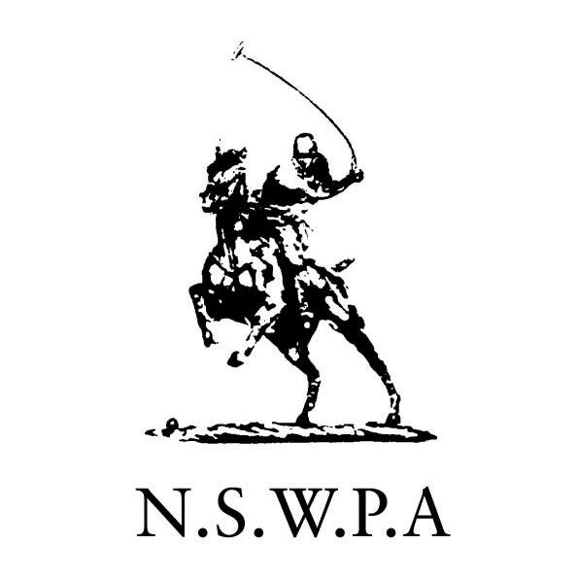
The Dudley Cup – 2008
PAYMENT OF CHUKKA FEES
This weekend, the Windsor Polo Club is collecting chukka fees on behalf of NSWPA. We would like to encourage all players to pay chukka fees in advance via DIRECT DEPOSIT into the WPC account.
Please reference this by - team name/your name or initials
- Account Name: Windsor Polo Club Inc
- BSB: 032016
- Account No: 981751
Please advise Eugene Marais by email that payment has been made – eugene@shorewater.com
Chukka fees have been set by NSWPA at $20 per chukka across all grades.
- A Grade - 12 goal, 6 chukkas, three matches - $360 per player
- B Grade - 6 goal, 5 chukkas, three matches - $300 per player
- C Grade - 2 goal, 4 chukkas, two matches - $160 per player
- D Grade - 0 goal, 4 chukkas, two matches - $160 per player
- E Grade - -2 goal, 4 chukkas, two matches - $160 per player

A payment desk will be set up and manned by Mike Fitzgerald at the WPC Club House between 9 am to 12 noon, Saturday 31 May
The club has a mobile EFTPOS machine available at each tournament. Cheques and Cash are also accepted.
Sponsored teams that require tax invoices are requested to notify us when lodging your nominations, so that the invoices can be prepared in advance.

Outstanding fees on Sunday morning will be called for by the commentators via the public address system

