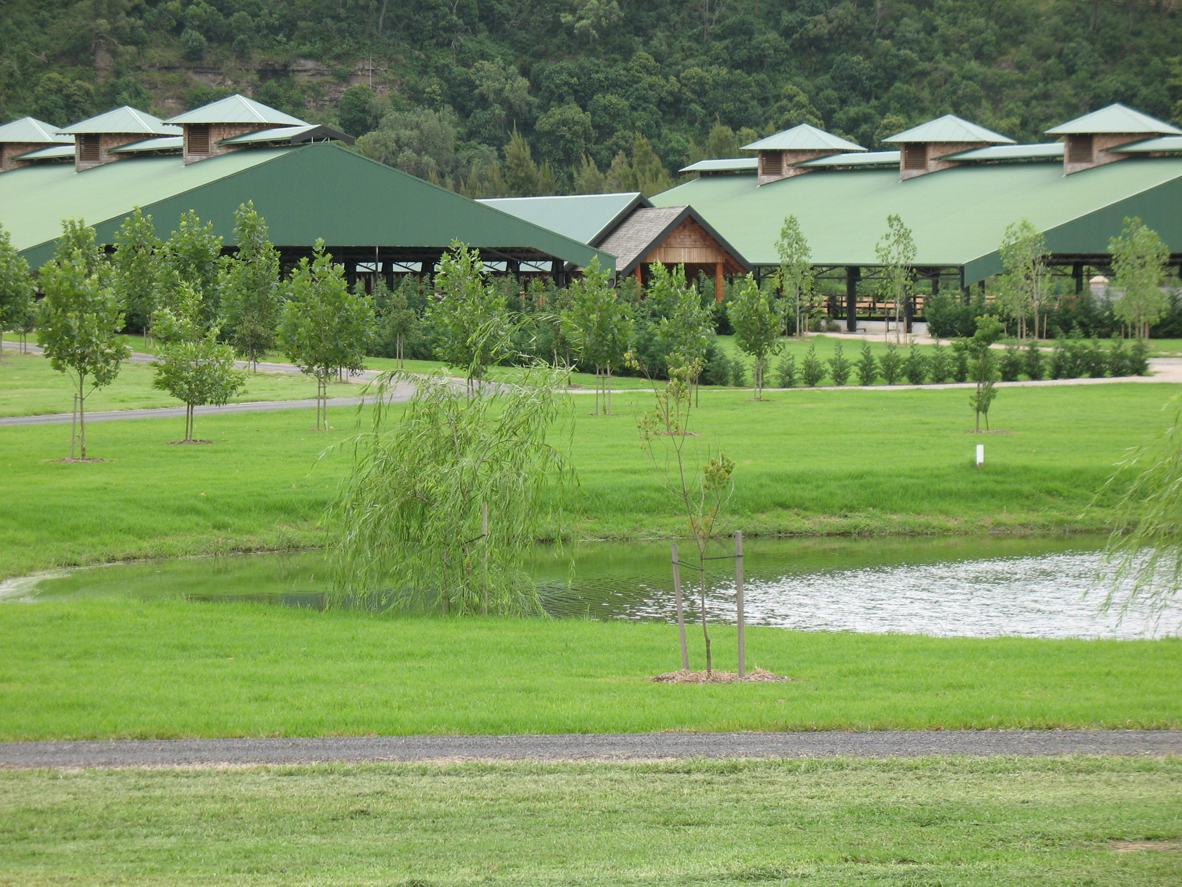
Sydney International Polo Pony Sale 2nd October 2009 Nomination Form: ENTRIES CLOSE 14TH AUGUST 2009
NAME OF HORSE

DOB / / | SEX

HEIGHT | BREED

IS THE HORSE A WINDSUCKER
(please tick) YES NO
HORSES PEDIGREE

SIRE

DAM
NOVICE  Has stick and balled |  | INTERMEDIATE  More experienced sound horses |  | ADVANCED  Medium / high goal
Reserve price  $ |  | Reserve Price  $ |  | Reserve Price  $
No Reserve Price  (please tick) |  | No Reserve Price  (please tick) |  | No Reserve Price  (please tick)
- These categories will be subject to approval by Horse Inspection Officer Greg Ballard
PERFORMANCE HISTORY / AUCTION WRITE UP
(Should include comment on horses performance history, paces, performance highlights or pedigree)
HORSES MARKINGS

HEAD | MICROCHIP
NEAR FORE | OFF FORE
NEAR HIND | OFF HIND
BRAND NEAR SIDE | BRAND OFF SIDE
OTHER MARKINGS
(Whorls and scars
must be included)

OWNER INFORMATION

FULL NAME

ADDRESS
SUBURB | STATE | POSTCODE
PHONE | FAX
MOBILE | EMAIL
FULL NAME

ADDRESS
SUBURB | STATE | POSTCODE
PHONE | FAX
MOBILE | EMAIL
ABN | ARE YOU REGISTERED FOR GST
PAYABLE TO (cheque will only be issued to one payee)

Conditions:
- No entry fee
- No commission on horses passed in
- 5% commission on horses sold

- We strongly recommend horses are stable on the premises from Tuesday the 29th September to take advantage of organised chukkas, inspections and marketing. Agnes Banks Equine Clinic will also be on premises for vet inspections. ( days and times to be confirmed)
- Horses recommended arrival date and time is Tuesday 29th September. Gates will be opened 8am Tuesday and locked at 5pm.
- 24 hour security on site from Tuesday 29th from 6pm till Friday 2nd October 5pm.

DO YOU REQUIRE  STABLING (please tick) | YES |  | NO
WHAT DAY WILL YOU BE ARRIVING
COST STABLES $30/NIGHT YARDS $10/NIGHT
MONDAY
TUESDAY
WEDNESDAY
THURSDAY
FRIDAY
SATURDAY
SUNDAY
HAY CAN BE PURCHASED AT $15/BALE
HOW MANY BALES DO YOU REQUIRE

DO YOU REQUIRE YOUR HORSE PREPARED FOR SALE.  i.e. Feeding, exercising, washing etc.  Please contact:  Rob Ballard  +61407 315 760 | (please tick)
NAME AND NUMBER OF PERSON LOOKING AFTER HORSE DURING THE EVENT
STICK AND BALL AND ORGANISED CHUKKAS WILL BE AVAILABLE BY ARRANGEMENT.  If YOU’RE INTERESTED Please contact Greg Ballard +61418521401 or Brodie Donovan +61410314765 | (please tick)
OFFICE USE ONLY
LOCATION OF
HORSE DURING EVENT
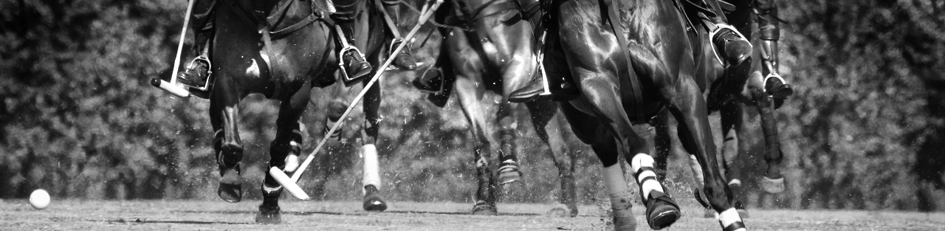

MARKETING

What better way for your business to advertise than in our Sydney International Polo Pony Sale Catalogue, where you will be talking to the right people? The catalogue will display all the nominated horses and be mailed to all international prospective purchasers as well as being available at no cost on the day. Why not promote your stallion’s service or even a more extensive marketing plan for your nominated horse.

Would you like to advertise?  (please tick) | YES | NO

¼ PAGE BLK/WHT | $40.00
½ PAGE BLK/WHT | $80.00
FULL PAGE BLK/WHT | $120.00
FULL PAGE COLOUR | $250.00
Would you like your horse marketed via our internet lot viewing catalogue?  (please tick) | YES | NO
Can you provide a photo?  (please tick) | YES | NO
PLEASE CHOOSE FROM THE FOLLOWING OPTIONS:
(Please tick)

