Sunday

10am Match 5 Losers of Matches 1& 2
Beaten B Grade: The W.J. Maslin Memorial Trophy

Umpires –
Goal Umpires – Teams from Match 7

Winners

11am Match 6 Losers of Matches 3&4

Beaten A Grade: The Kibah Cup

Umpires –

Goal Umpires – Teams from Match 8

Winners

1pm Match 7 Winners of Matches 1&2
Final B Grade: The D.H. Edwards Cup

Umpires –

Goal Umpires –Teams from Match 5

Winners

2.30pm Match 8 Winners of Matches 3&4
Final A Grade: The Gunnedah Polo Club Cup

Umpires –

Goal Umpires –Teams from Match 6

Winners

WARNING!
Beware at all times of horses and polo balls
Entry to the polo ground is at your own risk
No unauthorised vehicles on the playing surface or within the safety zone
Dogs must be on a lead at all times
Children must be supervised at all times
All spectators are to remain ten (10) metres from the sideline
Helmets to be worn by all riders
Alcohol consumption by umpires and goal umpires is not permitted
All goal umpires must be reg. Players and must wear helmets.

Gunnedah Polo Club
2010 Carnival
Gunnedah Polo Club

Gunnedah Polo Club

Saturday 28th & Sunday 29th August
McHardy Polo Ground at Spring Ridge
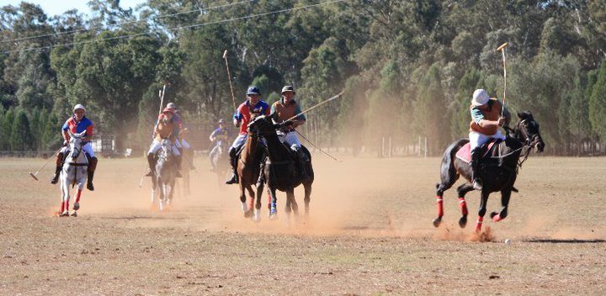

Patron: Mr George Witts
President: Ben Osborne
Secretary: Renata Davidson
Treasurer: Ben Osborne
Club Captain: Phil Clift

Trophies to be Played for
Gunnedah Polo Club Cup (A Grade)
The Kibah Cup (Beaten A Grade)
The D.H. Edwards Cup (B Grade)
The W.J. Maslin Memorial Trophy (Beaten B Grade)

Pony Prizes
A Grade Pony – Donated by the late Mrs S Masllin
B Grade Pony – Donated by Marge Clift
The Douglas Baker Trophy for Team of Club Ponies
Donated by Mrs B Baker
The Club Pony – Donated by the Witts Family
Pony Played by a 0 Goaler or less – Donated by the Alker Family
The Don Clift Trophy for Best and Fairest Player

Teams Competing in A Grade

Scone Quirindi A
1. Nigel Russell -1 1. James Hockey 0
2. Doug Munro 1 2. Mark Barber 1
3. Sam Gunn 3 3. Dick Doolin 3
4. Andrew Badgery 1 4.Rob Doolin 1
4 5

Quirindi B North Star
1. Malcom Purshouse 0 1. Angus Doolin 1
2. Scott McCreery 1 2. Nick Benson 0
3. Mike McKechnie 2 3. Adam Tolhurst 4
4. Rob Davies 0 4. Simon Doolin 1
3 6

Teams Competing in B Grade

Tamarang B Gunnedah A
1. Andrew Campbell -2 1. Max O’Leary -1
2. Peta Gay Railton 0 2. Melissa McCarthy 0
3. Sam Gunn 3 3. Phil Clift 2
4. James Simson -1 4. Gerad O’Leary 0
0 1
Tamarang A Gunnedah B
1. Scott Chambers -1 1. Damien Allport -1
2. Dennis Lee 0 2. Russel May 1
3. Jim Henry 2 3. Scott McCreery 1
4.Tim Skerrett 0 4. Toby Scales 0
1 1

The Draw

Saturday

B Grade (4 chukkas)
Match 1 - 10am Tamarang B vs Gunnedah A
Umpires: Mark Barber & Rob Davies
Goal Umpires: James Hockey, Rob Doolin/Nigel Russell, Doug Munro

Winners:

B Grade (4 Chukkas)
Match 2 – 11am Tamarang A vs Gunnedah B
Umpires: Andrew Badgery & Mike McKechnie
Goal Umpires: Angus Doolin, Nick Benson/Malcom Pursehouse, Rob Davies

Winners:

A Grade (5 chukkas)
Match 3 – 1pm Quirindi A vs Scone
Umpires: Phil Clift & Adam Tolhurst
Goal Umpires: Max O’Leary, Melissa McCarthy/Andrew Campbell, James Simson,

Winners:

Match 4 - 2.30pm Quirindi B vs North Star
Umpires: Jim Henry & Dick Doolin
Goal Umpires: Scott Chambers, Tim Skerrett/Damien Allport, Toby Scales

Winners:

Dinner on Saturday night will be at the Royal Hotel, Spring Ridge.

The Gunnedah Polo Club would like to thank Ron and Di McHardy for the continued use of their grounds.

