**Thank you to our Sponsors**



All are invited for Dinner and drinks Saturday night at the Park view Hotel, Gunnedah





**Hockings Ag Spray**

**0487345069**

**C:\Users\User\Documents\Polo\2014\Omega Feeds logo.tiff**



Thankyou to AMPS &Pursehouse Rural for the

use of their tents & cool room

**Gunnedah Polo Club**

**Saturday 29th & Sunday 30h August 2015**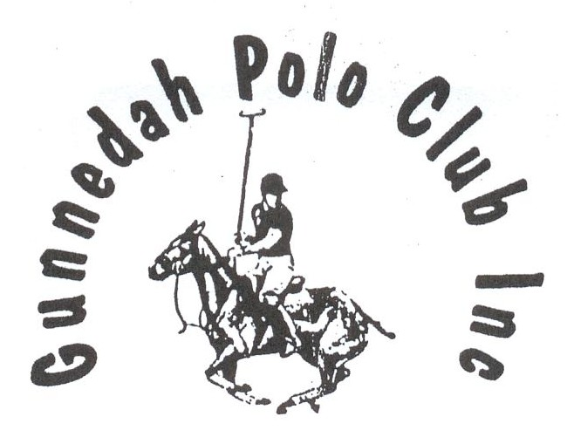

**Patron: Mr George Witts**

**President: Mark Barber**

**Secretary: Renata Davidson**

**Treasurer: Ben Osborne**

**Club Captain: Phil Clift**

**Trophies to be Played for**

**Gunnedah Cup (A Grade)**

**The Kibah Cup (Beaten A Grade)**

**CH Edwards Cup (B Grade)**

**The W.J. Maslin Memorial Trophy (Beaten B Grade)**

**The K.C Murchison Cup (C Grade)**

**The Presidents’ Trophy (Beaten C Grade)**

**Gunnedah Club Trophy (D Grade)**

**A Grade Pony – Donated by the Maslin Family**

**B Grade Pony – Donated by Mrs M Clift**

**The Douglas Baker Trophy for Team of Ponies**

**Donated by Mrs B Baker**

**The Club Pony – Donated by the Witts Family**

**C or D Grade Pony Played by a 0 Goaler or less**

**Donated by the Alker Family**

**The Don Clift Trophy for Best & Fairest Player**

**Donated by Clift family**

**B&H Mazoudier Memorial for Best & Fairest Junior in the Junior Competition**

**Donated by L Mazoudier**

**Most Improved Gunnedah Player**

**Donated by the Parkview Hotel**

Saturday

C Grade (Round Robin)

**Match 1 – 8.45am Gunnedah vs Tamarang**

**Match 2 – 9.15am Gunnedah** **vs** **Tamworth**

**Match 3 – 9.45am Tamarang vs** **Tamworth**

Umpires: G Boonzaaier & E Herbert

Goal Umpires: Carmyle & Goondiwindi

**Gunnedah Tamarang**

1. Katrina Osborne -21. Andrew Campbell -1

2. Ben Osborne 1 2. Scott Chambers 0

3. Phil Clift 1 3. Jimbo Henry 2

4. Mark Barber 2 4. Dennis Lee 0

**2 1**

**Tamworth**

1. Bryce McMurtrie 0

2. Tim Skerrett 0

3. James Hockey 1

4. Bernard Cuskelly 0

**1**

**Match 4 – 10.15am** C Grade (4 Chukkas)

**Downs** **vs** **Scone**

1. Hayden O’Leary -1 1. Dan Blackman -2

2. Paul McGinley 0 2. Nigel Russell 0

3. Earl Herbert 3 3. Brad Bestson 2

4. Gerard O’Leary 0 4. Harry Foley 0

**2** **0**

Umpires: - P Clift & E Hill

Goal Umpires: Warrah Creek & Ringers

**Match 5 - 11.15am** B Grade (4 chukkas)

**Carmyle vs Goondiwindi**

1 Ricky Mitchell 0 1. Sam Coulton -1

2. Will Simson 1 2. Andrew Coulton 0

3. Al Simson 1 3. Will Gilmore 4

4. Gus Boonzaaier 3 4. Tom Coulton 0

**5 3**

Umpires: A Gunn & J Henry

Goal Umpires: Ellerston & Branch Creek

**Match 6 – 12.15pm** B Grade (4 chukkas)

**Warrah Creek**  **vs** **Ringers**

1. Jack Grimes -2 1. Russell May 0

2. Peter Grimes 1 2. Dave Bettington 1

3. Matt Grimes 6 3. Eustie Hill 1 4. Malcom Pursehouse -1 4. Jimbo Henry 2

**4 4**

Umpires: G Hill & N Benson

Umpires: North Star & Quirindi

**Match 7 –** **1.15pm** Junior Match (1 Chukka)

**Foul Hookers vs T-Boners**

1. Julia Chambers -2 1. Harry Davidson -2

2. Jack Davidson -2 2. Lachie Clift -2

3. Sam Osborne -2 3. Codie Grimes -2

4. Glen Gilmore 7 4. Matt Grimes 6

**1 0**

Umpire: G Kirkpatrick

**Match 8 – 1.30pm** A Grade (5 Chukkas)

**Ellerston vs Branch Creek**

1 Witney Warren 0 1. Scott McCreery 1

2. Doug Munro 1 2. Angus Scott 2

3. Angus Gunn 2 3. Guy Kirkpatrick 5

4.Glen Gilmore 7 4. Barry Moule 0

**10 8**

Umpires: W Gilmore & A Simson

Goal Umpires: Tamarang & Tamworth

**Match 9– 2.45pm** A Grade (5 chukkas)

**Quirindi vs North Star**

1. Mick Hockey 1 1. Nick Benson 2

2. James Hockey 1 2. George Hill 2 3. Matt Grimes 6 3. Gus Boonzaaier 3

4. Rob Davies 1 4. Simon Doolin 2

**9 9**

Umpires: D Bettington & G Gilmore

Goal Umpires: Downs & Scone

**Sunday**

**Matches 10,11 & 12 - 8.45am** (Round Robin)

**Presidents’ Trophy**

**Beaten C Grade from Matches 1,2,3 & 4**

*Goal Umpires – Teams from Match 14*

***Winners Tamarang 3 vs Scone ½***

**Match 13 – 10.15am The W.J Maslin Memorial Trophy**

**Beaten B Grade from Matches 5 & 6**

Goal Umpires – Teams from Match 15

**Winners Carmyle 5 vs Ringers 3**

**Match 14 - 11.15am KC Murchison Cup**

**C Grade Final Winners from Matches1, 2, 3 & 4**

Goal Umpires – Teams from Match 17

**Winners Downs 5 vs Gunnedah 5 (coin toss to Downs)**

**Match 15 - 12.15pm Kibah Cup**

**Beaten A Grade from Matches 8 & 9**

Goal Umpires – Teams from Match 18

**Winners Branch Creek 4 ½ vs Quirindi 4**

**Match 16 – 1.30pm Junior Competition**

**T-boners & Foul Hookers Final**

**Winners**

**Match 17 – 1.45pm CH Edwards Cup**

**B Grade Final Winners of Matches 5 & 6**

Goal Umpires –Teams from Match 10

**Winners Warrah Creek 5 vs Goondiwindi 4.5**

**Match 18 – 2.45pm Gunnedah Cup**

**A Grade Final Winners of Matches 8 & 9**

*Goal Umpires –Teams from Match 13*

***Winners Ellerston 5 vs North Star 4 ½***