Z
ELLERSTON POLO
A.B.N. 50 123 039 341

ELLERSTON via
SCONE NSW 2337
AUSTRALIA

Ph. +61 2 6540 7282
Fx. +61 2 6546 5100
Email. polo@ellerston.com

July 30, 2026
ELLERSTON POLO CLUB

30 July 2026

Dear Patron’s and Player’s

Ellerston Polo Club will be holding the Archibald-Cudmore Trophy 8 Goal Polo Tournament from Saturday the 5th October to Sunday the 13th October 2013. I would like to invite teams to nominate for this tournament.

A Ground Fee of $5000.00 per team will be required to participate in this Tournament. A Tournament requirement is that all Players must be fully affiliated with the A.P.C.

Some accommodation for Players and Grooms, as well as stabling, can be provided at “Ellerston”. However due to the restricted amount of accommodation and stabling available, priority will be given to non local players. The Ellerston Store, Clubhouse and Breakfast Room will be open daily for all catering requirements during the Tournaments. Eftpos facilities are available at “Ellerston”. No accounts will be accepted.

Nominations must be confirmed by providing the completed Nomination Form and Ground Fee by Friday the 13th September 2013. Please forward all nominations and correspondence to my Secretary, Sue Finn. For the payment of the Ground Fee by direct deposit, please find the Ellerston Bank Account details on the Nomination Form. For any further queries Sue can be contacted on the telephone number listed above or at home: (02) 6540 7420

We look forward to continued support from our polo friends.

Yours sincerely
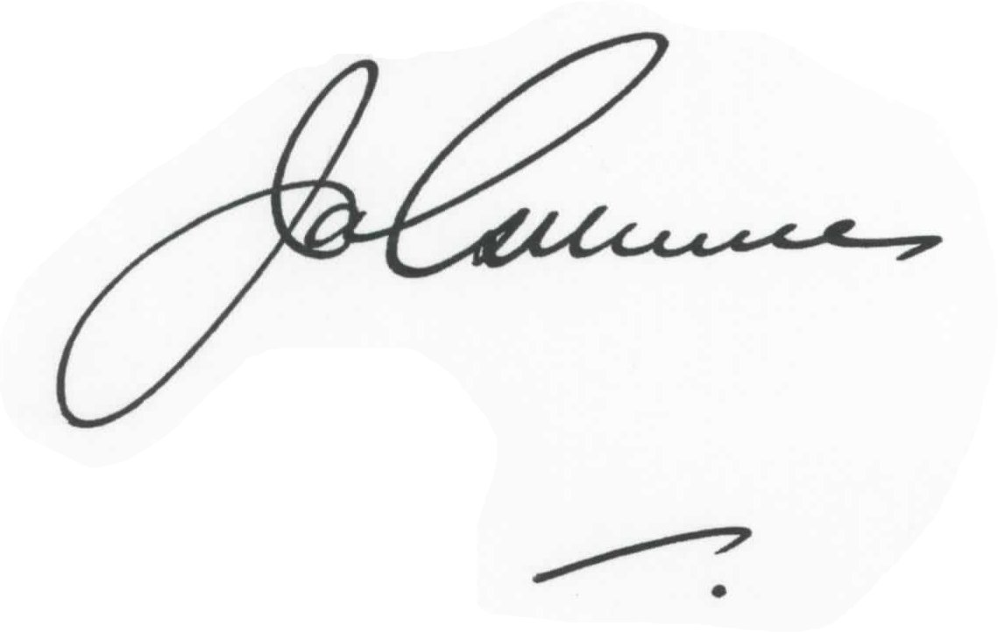
James Gilmore
Ellerston Polo Manager

