Z
ELLERSTON POLO
A.B.N. 50 123 039 341

ELLERSTON via
SCONE NSW 2337
AUSTRALIA

Ph. +61 2 6540 7282
Fx. +61 2 6546 5100
Email. polo@ellerston.com

July 30, 2026
ELLERSTON POLO CLUB

30 July 2026

Dear Patrons and Players

Ellerston Polo Club is holding the Ellerston Spring Trophy 16 Goal Polo Tournament from Saturday the 5th October to Sunday the 13th October 2013. We would like to invite you to nominate a team to participate in this year’s event.

A nomination fee of $5,000.00 is required to accompany your nomination. Nominations close on Friday the 13th September 2013.

The tournament will operate on the same format as last year with breakfast, lunch and dinner services available for the duration of the tournament. Accommodation is provided at Ellerston for the team’s (including immediate family) and staff only.

Together with the Melbourne and Garangula Polo Tournaments we are hoping to provide a great season of spring polo of a handicap level suitable to you all. We hope you can again join us this spring.

Yours sincerely
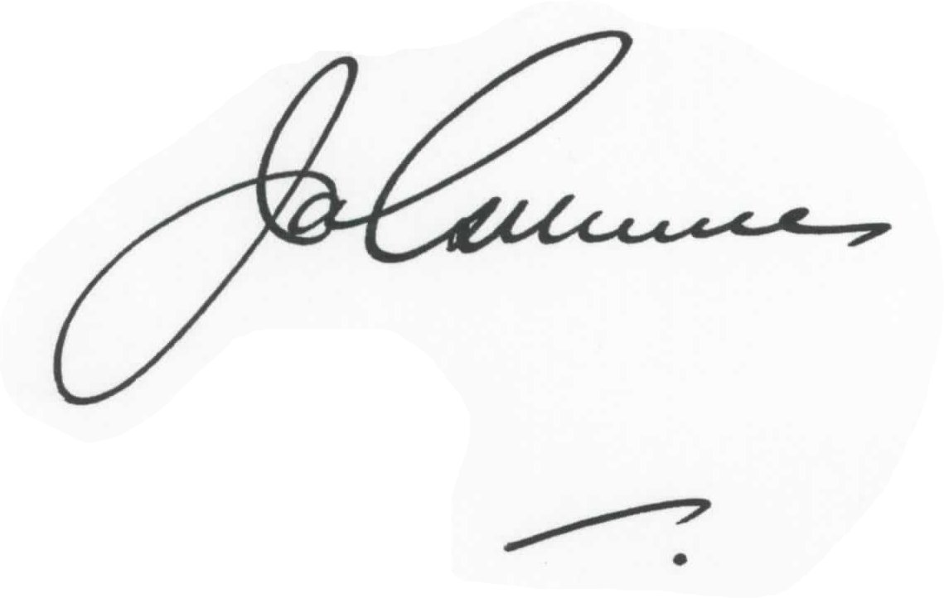
Jim Gilmore
Ellerston Polo Manager

