31 July, 2026
Z
ELLERSTON POLO
A.B.N. 50 123 039 341

ELLERSTON via
SCONE NSW 2337
AUSTRALIA

Ph: +61 2 6540 7282
Fx: +61 2 6546 5100
Email: polo@ellerston.com
Jim Mobile: 0403 263 020
Sue Mobile: 0419 708 151
ELLERSTON POLO CLUB

Dear Patrons and Players
As you know I have had to cancel the March Polo Tournaments at Ellerston due to the continued dry conditions. The tournament has been relocated to the Hawkesbury Basin thanks to the generosity of a number of clubs based around Richmond.

ELLERSTON 8 GOAL TOURNAMENT
Saturday, 8th March to Sunday, 16th March 2014
A nomination fee of $5,000.00 for the Tournament should accompany your completed entry. Nominations close on Friday 14th February 2014 and a maximum of 8 teams will be accepted. In addition, all players must be fully affiliated with the Australian Polo Council.
Stabling is being organised by Ellerston in conjunction with the Hawkesbury clubs. By our calculation stabling and paddocks will be very limited. With this in mind, horse accommodation for those teams and players not based at Richmond, will be allocated stabling/paddocks for 7 horses per player.
Please forward all nominations and correspondence to my Secretary, Sue Finn. Sue can be contacted on the telephone numbers listed above or at home: (02) 6540 7420.
I am sure with the generous support of our polo friends at Richmond we can look forward to another exciting tournament.
Yours sincerely

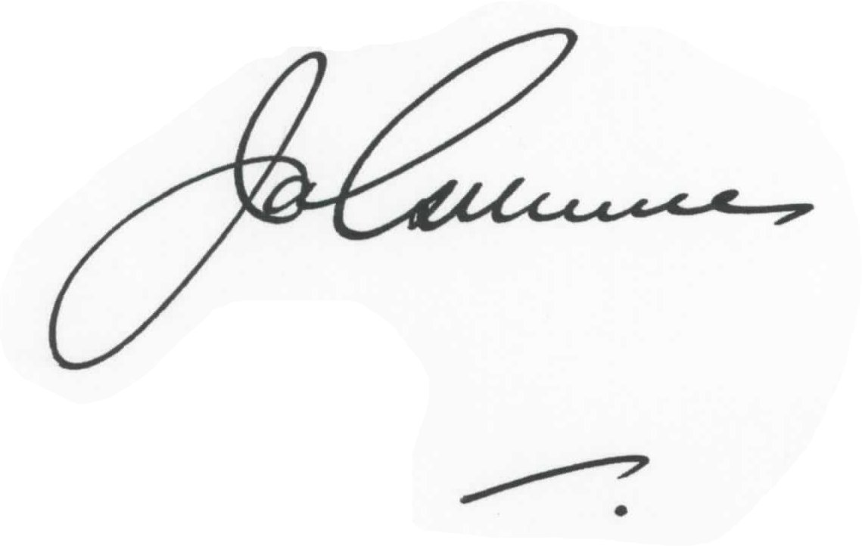
James Gilmore

Ellerston Polo Manager

